- Purpose
  - The purpose of this document is to describe the procedure for prepping and checking a Crewman AS20B machine before shipment.
- Scope
  - This SOP applies to all equipment assembly team members. The process applies to the following machine ID’s:
E029967PKG0600BE1200 – Crewman AS20B w/2-12V 110AH AGM Bat, 12 Amp Charger w/solenoid
E029968PKG0600BE1200 – Crewman AS20B w/2-12V 115AH Wet Bat, 12 Amp Charger, Solenoid
E029968PKG0600RR1000 – Crewman AS20B w/2-12V 115AH Wet Bat, 12 Amp Charger, Brush, Solenoid
E029968PKG0602RR1000 – Crewman AS20B w/2-12V 115AH Wet Bat, 12 Amp Charger, Solenoid
E029969PKG0600BE1200 – Crewman AS20B w/2-12V 130AH Wet Bat, 12 Amp Charger, Solenoid
- Responsibilities
  - The operations manager/supervisor is responsible for enforcing this SOP.
- Materials
  - The proper materials needed for this process are listed on the machine work order.
- Definitions

- Procedure
  - Begin by taking a base machine (29999) out of the box. Set all of the components aside that come with it. The machine can stay on the skid for this process.

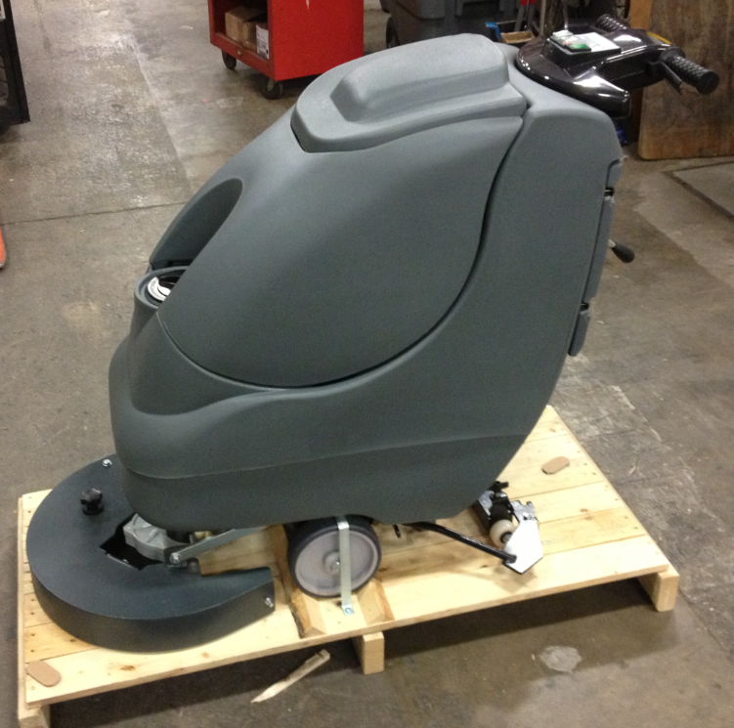

  - Check the switches on the console. Occasionally these can be damaged by the shipping box. Fix or replace the switches if necessary.

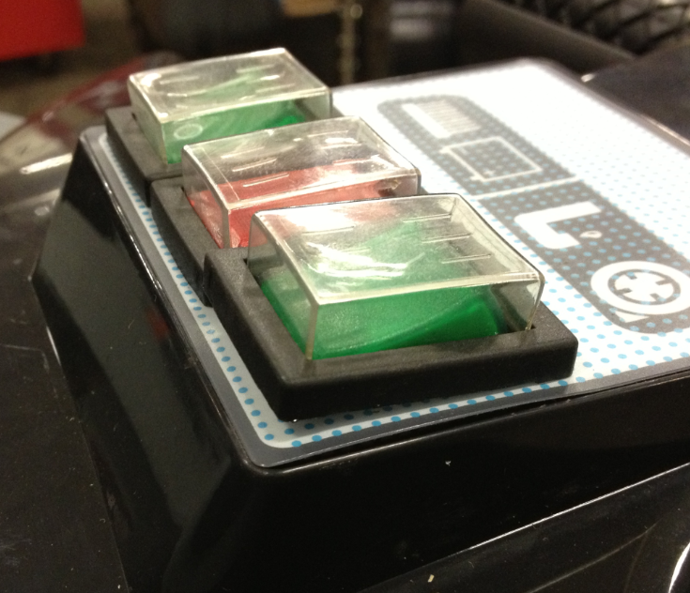
  - Remove the recovery tank from the machine. This can be set aside until later. Disconnect the two hoses shown first.

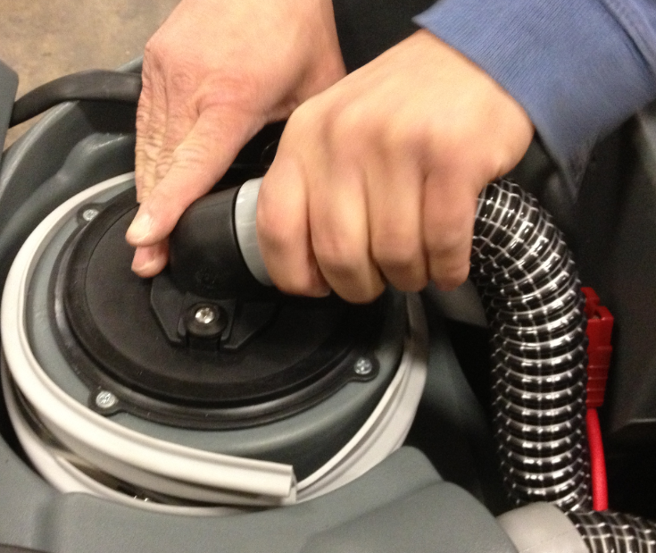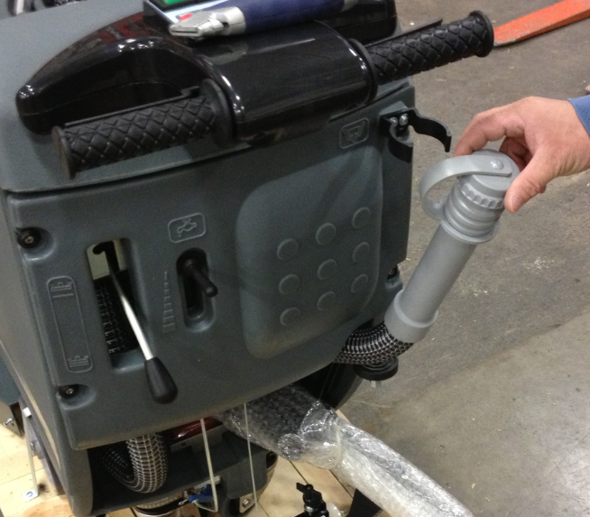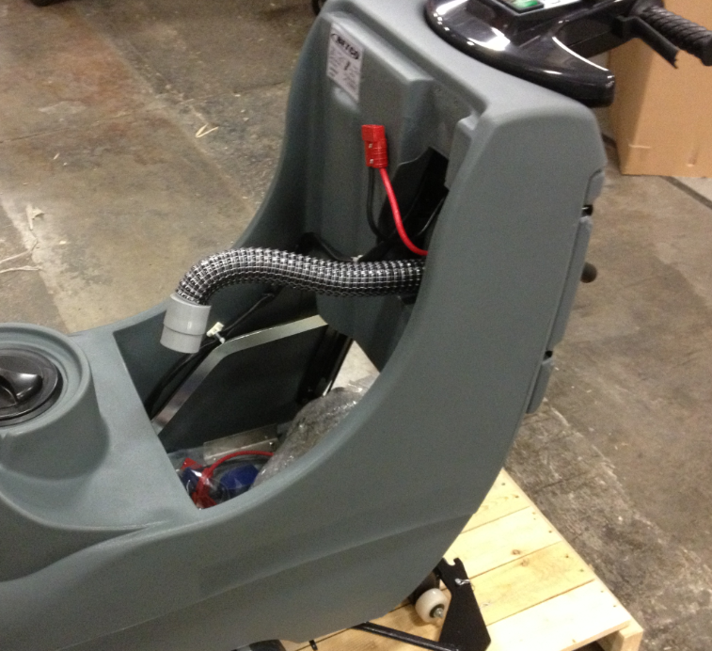

  - Remove the battery cables from the battery compartment.
  - Loosen the two screws that hold the battery bracket in the bottom of the compartment. Slide the bracket all the way back.

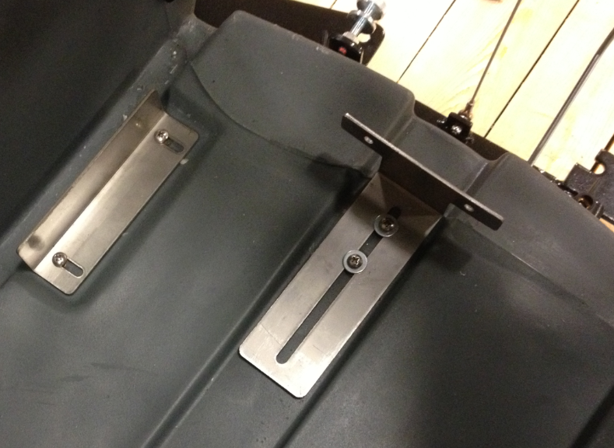

  - Place 1 battery into the battery compartment in the orientation shown. Be sure the terminals are on the side shown. Reference the work order to know which battery to use. (11767 or 86276 for wet cells and 88030 for AGM) For AGM batteries, place a Maintenance Free Battery Decal (88897) onto each battery.

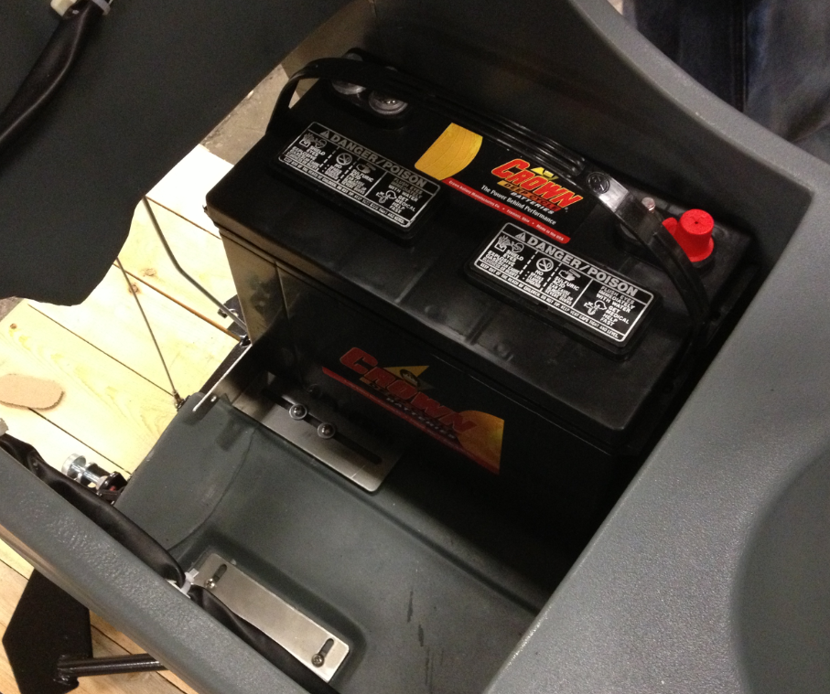

  - Slide the battery bracket forward until it touches the battery. Tighten up the screws to hold it in place.

  - Slide the battery to the other side of the compartment. Install the 2nd battery in the orientation shown.

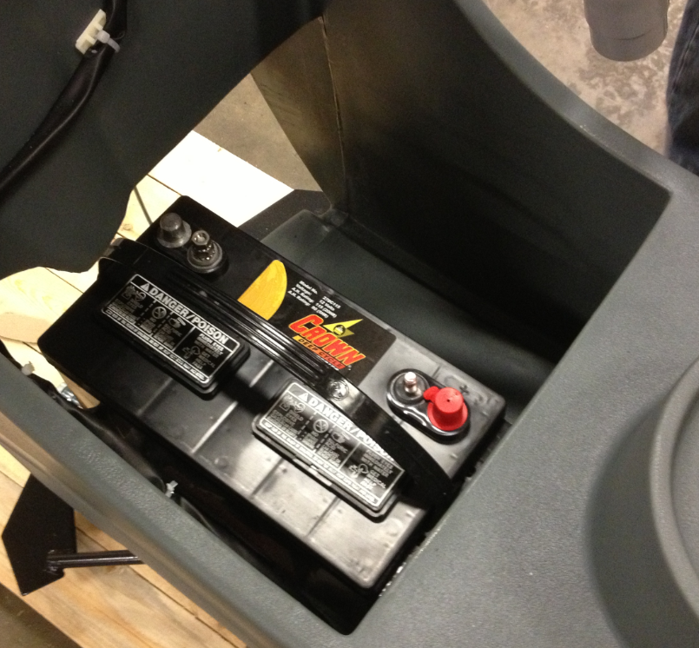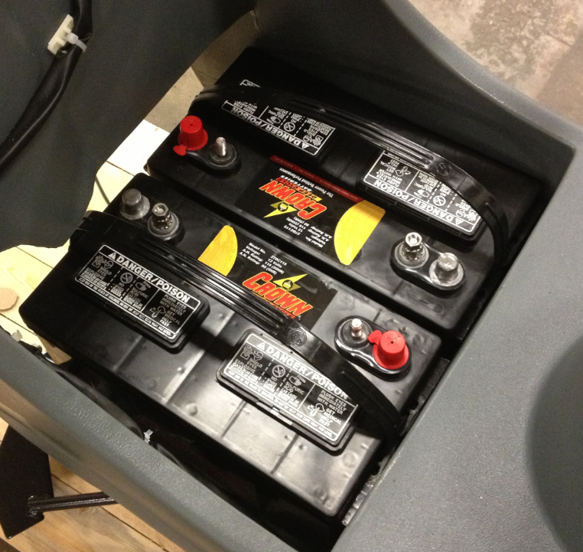

  - Use the cables provided to wire the machine. Use the photo as a template.

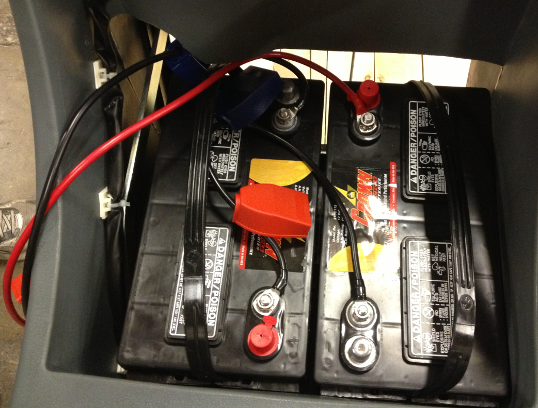

  - The machines arrive set for AGM batteries. If the machine has wet batteries in it, the setting on the card needs to be changed. Remove the screws that hold the two halves of the handle console together. Separate the two sides until the dip switches on the card are accessible. Locate the switch that controls the battery. Slide the switch away from the side that says “GEL”. Once complete, re-assemble the handle.

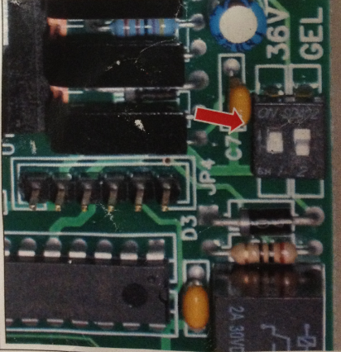

  - Connect the pigtail from the batteries to the machine.

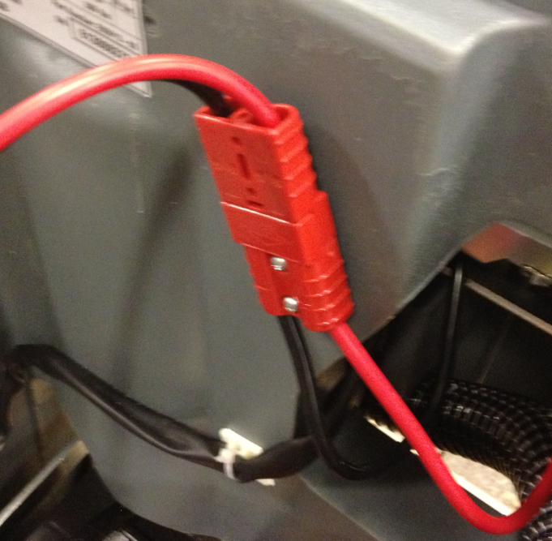

  - Put a ¼ gallon of washer fluid into the solution tank.
  - Press the button to turn on the vac motor. Place your hand over the end of the vacuum hose and verify that there is adequate suction. Turn the vac motor off if everything functions properly.

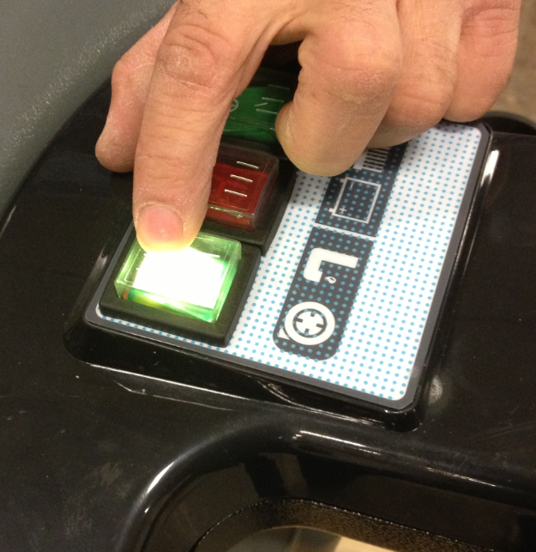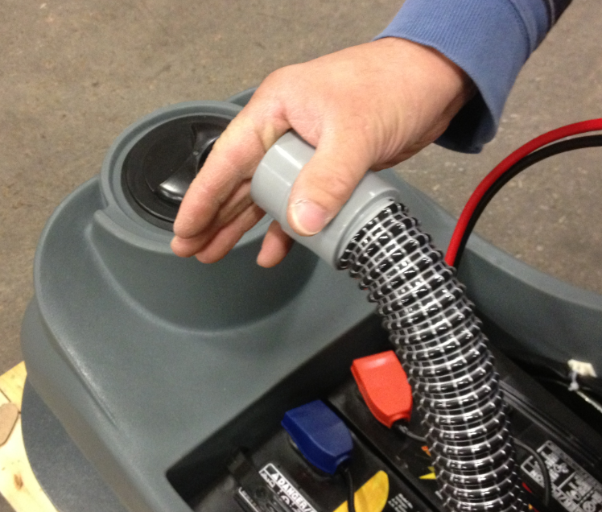

  - Check the drain plug on the rear of the machine and make sure that there are no leaks. Also check the connection between the hose and the fitting in the brush motor. Tighten the clamp if necessary.

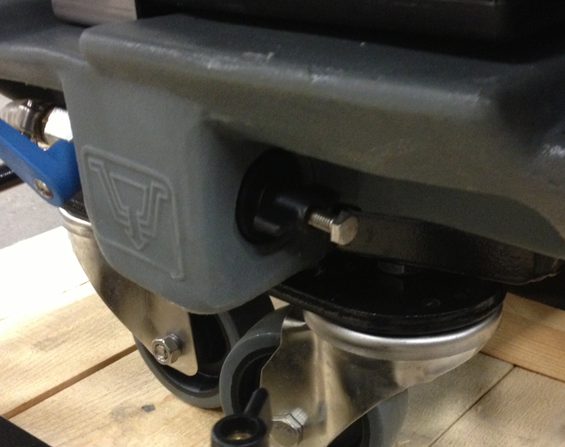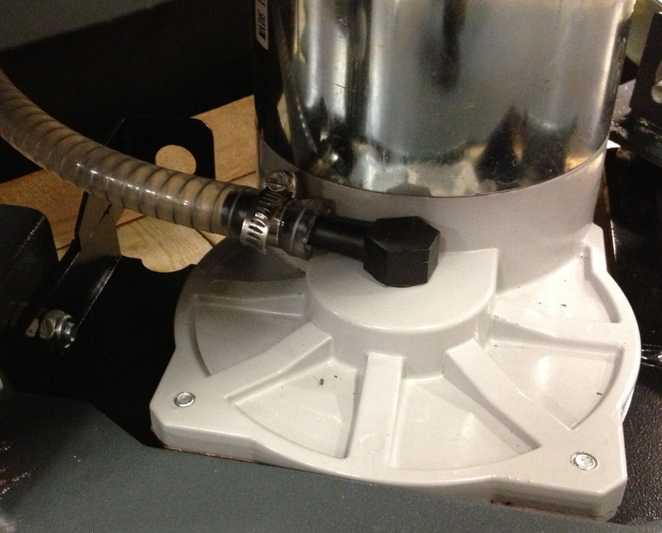

  - Press the button for the brush motor. Pull the handle trigger and verify that the brush motor turns properly.

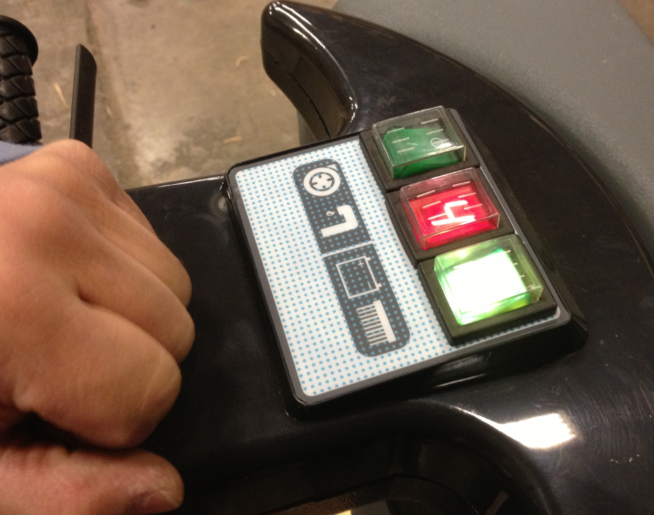

  - Open up the solution flow valve by using the solution flow lever. Pulse the motor a couple of times to start the fluid flow. Water should flow from under the deck.

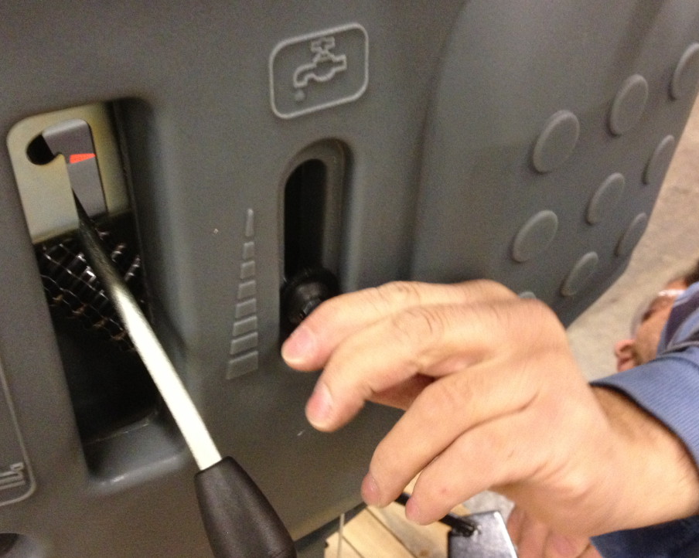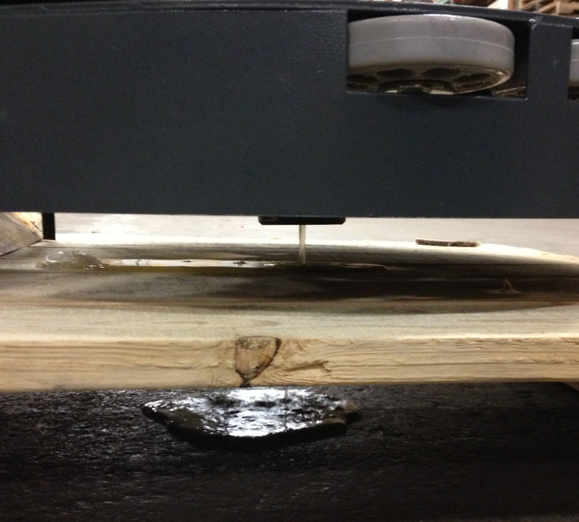

  - Verify that the BDI on the machine turns off when the solution valve is in the closed position. This shuts off the power to the machine. If the indicator remains on when the valve is closed you will need to remove the back panel of the machine and adjust the microswitch position.

  - If a machine is being built for R&R (RR1000), the switch that indicates that solution valve is closed needs to be disconnected. Remove the back panel by removing the 4 bolts that hold it in place. Once access to the switch is gained, disconnect the blue and brown wire shown. Re-install the panel.

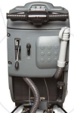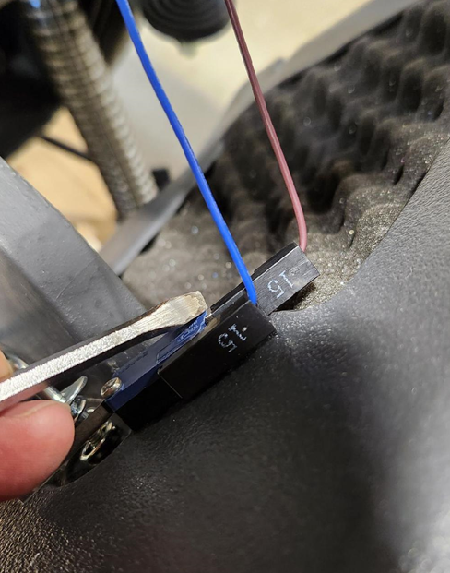

  - Place a Crewman Decal (83739) onto each side of the machine as shown.

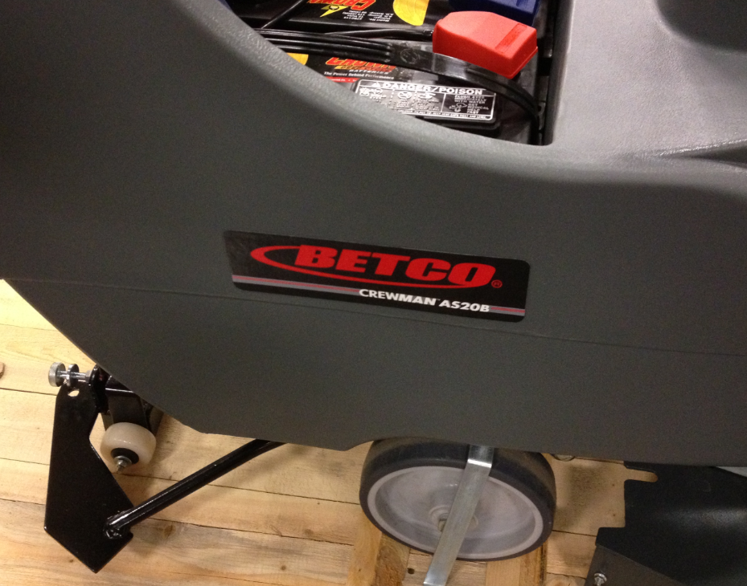

  - If any of the wheel brackets were dislodged or shifted during transport, line them back up over the wheels.
  - Use 1 band as shown to secure the machine to the pallet. Place the pad driver or brush on the side of the machine and use the band to secure it.

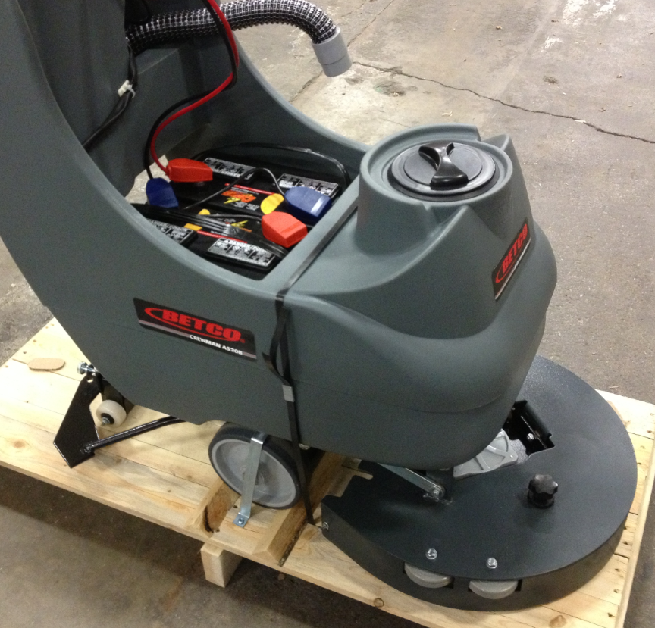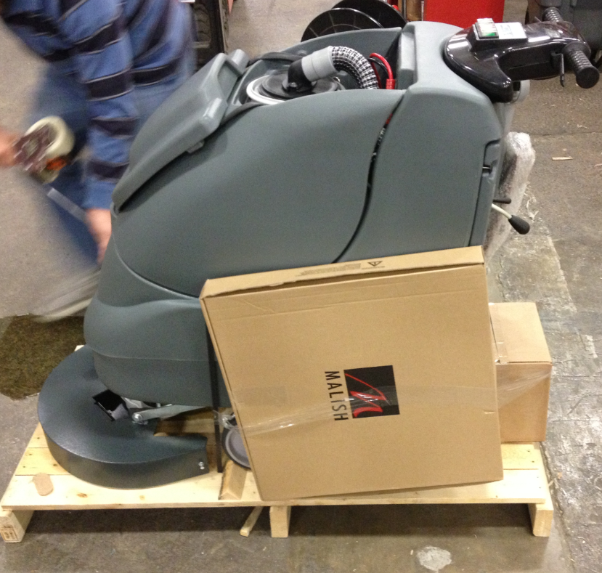

  - Place the recovery tank back onto the machine as shown. Reconnect the two hoses that were previously disconnected when the tank was removed.

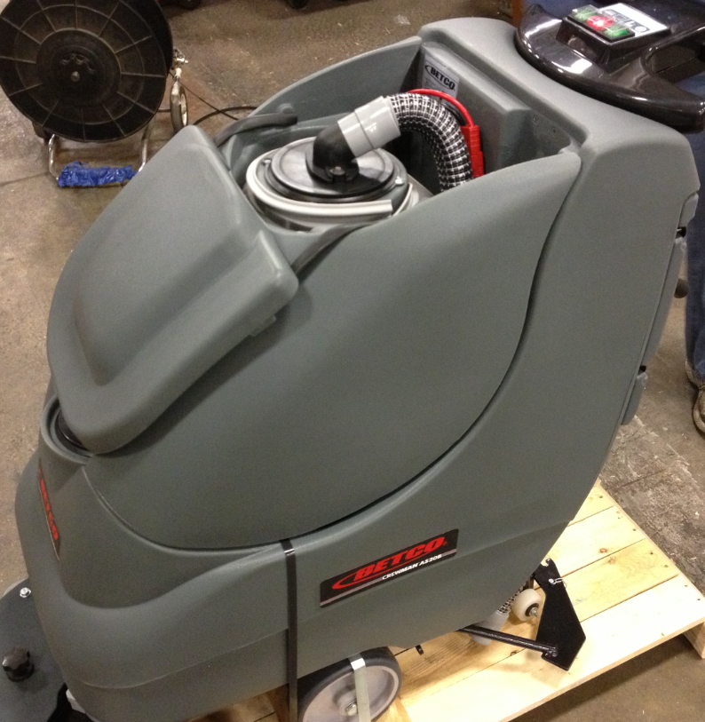

  - Place the charger (12610) on the back of the pallet as shown.

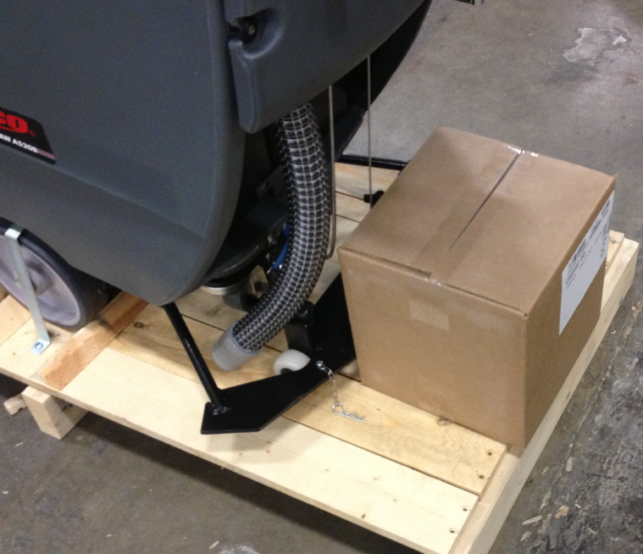
  - Disconnect the batteries from the machine.

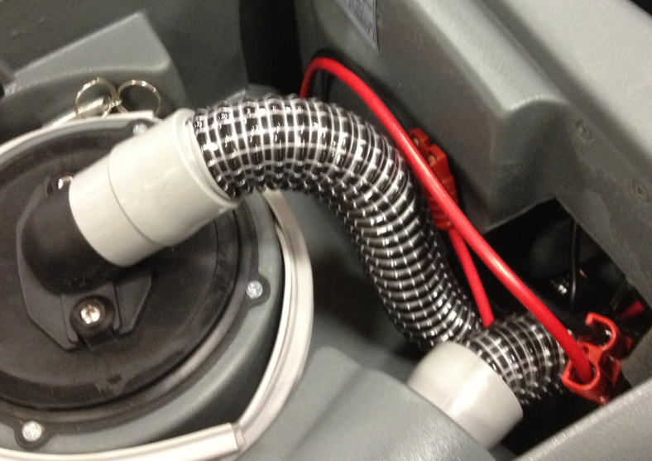

  - If a machine is being built for R&R (RR1000), there are 2 decals supplied by them that need to be placed. The R&R Sales decal (1) goes onto the handle in the location shown. The sticker with the defoamer note (2) goes on the recovery tank in the location shown.

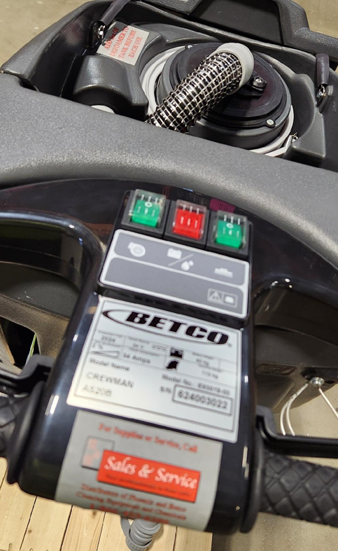
2
1

  - Put a manual packet together that includes a manual, a warranty card, a yellow QC tag, and wall charts. Place the packet under the lid as shown.

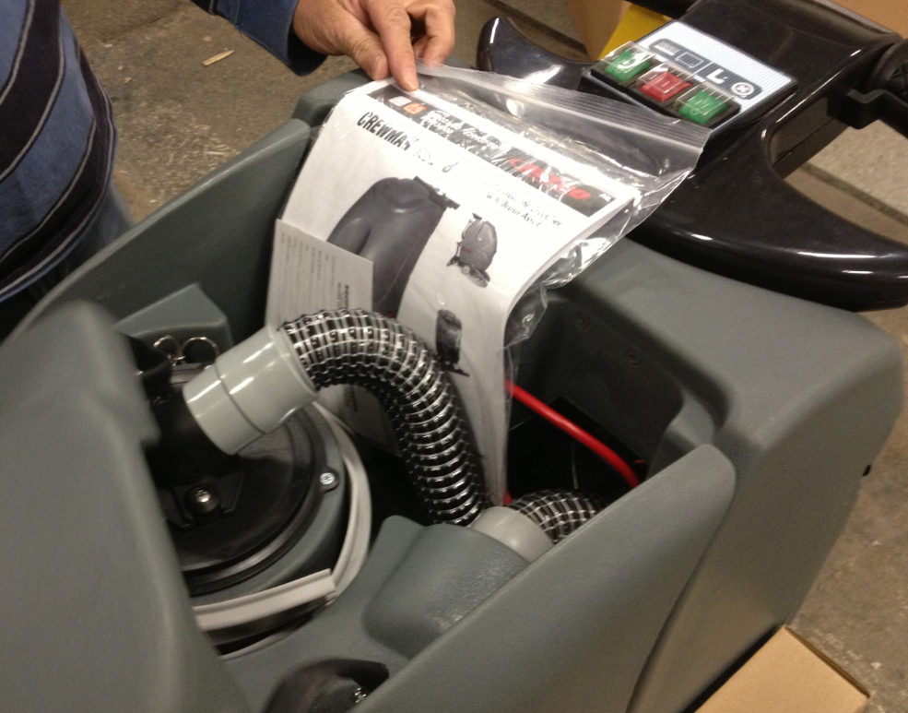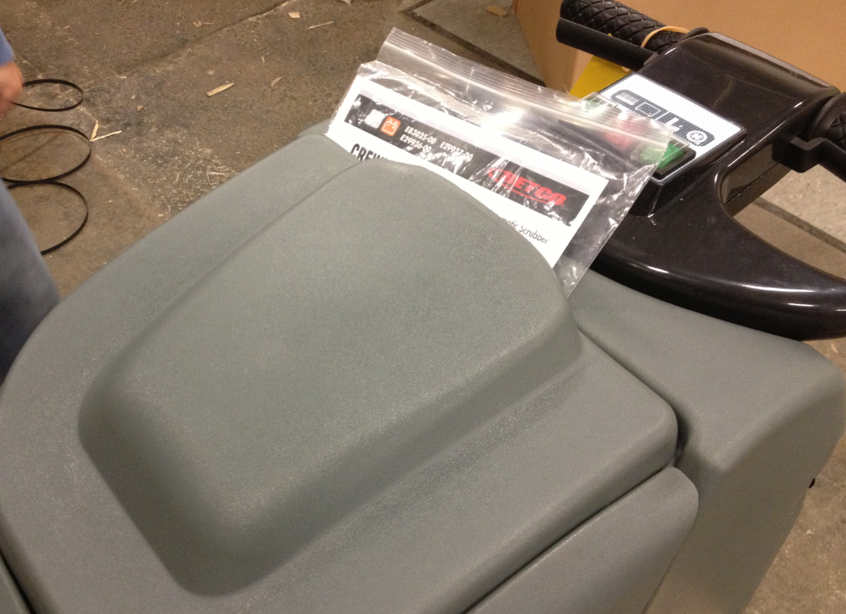

  - Place the plastic bag that covered that machine back over it. Use tape to secure the plastic bag on the machine.

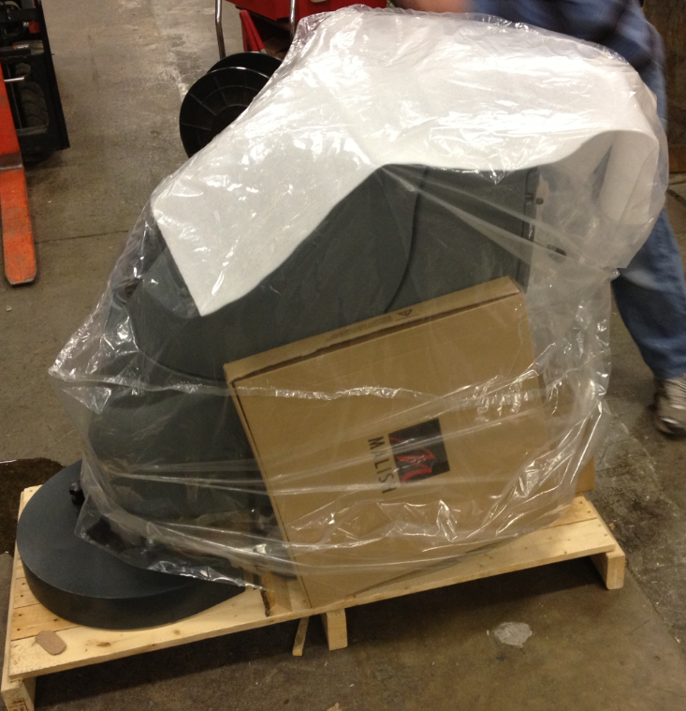

  - Place the shipping box back over the machine. Once the box is positioned properly, use 2 bands to secure it to that pallet.

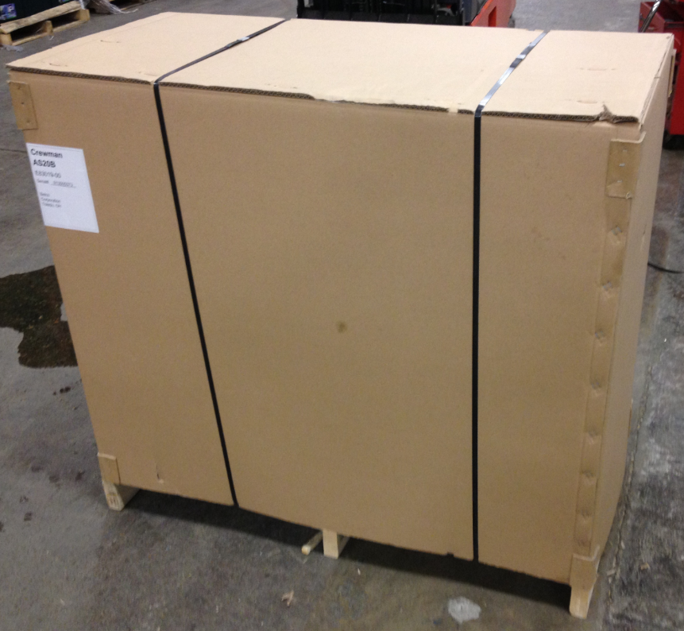
  - Place a machine ID sticker onto the box. It should cover up the old ID number of the machine.

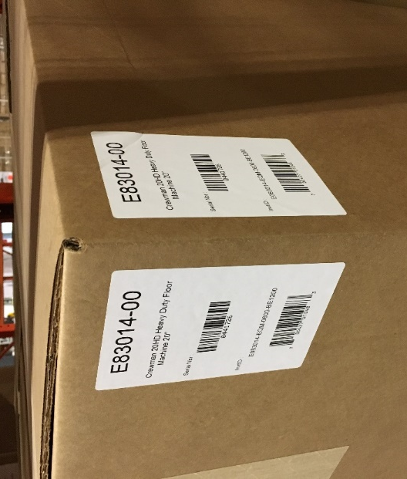

  - The machine is now ready for shipment.

- References (optional section as needed)

- Training Guide

Functional Training Groups Requiring Training
Equipment Group

- SOP Change Control

Date of Change | Reason for Change
Rev 01 | This is the first version of the S.O.P. hence there are no revisions to this document.
Rev 02 - 1/26/2018 | Added the Responsibilities Section
Rev 03 - 5/6/2025 | Updated for machines with Solenoid. Also added R&R customization

Approvals

Submitter/Author Approval:__________________________________ Date:______________________

Management Approval:______________________________________ Date:______________________

QAU Approval:_____________________________________________ Date:______________________

